[IAS Project] Ancri Carlo

Program behaviour
The program extracts features from audio files belonging to three different "classes" (crow, wind, and engine) and then trains classification models on this data. Features are extracted in both the time and frequency domains to analyze the signal from multiple perspectives. This program utilizes several scripts to ensure proper data processing: file_separator initializes the dataset in the correct format, extractAllFeats extracts all features in a compact and reliable manner, safe_normalize normalizes the data matrices and knnTrainer trains the models for classification.

file_separator
file_separator(masterFolderPath, folderNames)
Initializes the dataset by creating, for each considered class, two subfolders: 'training' and 'testing'. The files of each class are randomly shuffled, with 70% allocated to the 'training' folder and the remaining 30% to the 'testing' folder. The entire dataset and the newly created folders (if they did not already exist) are then added to the MATLAB path.

extractAllFeats
[TrFeatF, TrFeatT, TeFeatF, TeFeatT] = extractAllFeats(subFolPath, wL, sL)
It utilizes the functions freqFeatures and timedomainFeats to extract the relevant features in an organized manner from the given path ‘subFolPath’. The function returns four matrices, separating training and testing features as well as frequency-domain features from time-domain features.

safe_normalize
[matrix, mn, st] = safe_normalize(matrix)
This function normalizes the input matrix by transposing it, subtracting the mean ‘mn’ from each value, and dividing by the standard deviation ‘std’. It returns the normalized matrix along with the mean and standard deviation, which can be reused in subsequent code.

knnTrainer
[recognRate, Mdl] = knnTrainer(trainFeat, testFeat, labels, ground_truth, k)
By associating ‘trainFeat’ with corresponding ‘labels’ that identify the class of each feature, a classification model (Mdl) is trained. The model is then tested on ‘testFeat’, which are linked to labels not visible to the model (ground_truth). The model's performance is recorded in the recognRate vector for a given number of neighbors k(ind).

Algorithm used

k-NN
The k-Nearest Neighbors (k-NN) algorithm is a classifier that uses proximity to make classifications or predictions about the grouping of a single data point. This algorithm belongs to the family of "lazy learning" models, meaning that it only stores a training dataset instead of undergoing a dedicated training phase; all computations are performed only when a classification or prediction is needed. The key aspect of this algorithm is training the classification model on a quality dataset, as all future calculations will rely on it. k-NN is one of the simplest yet most accurate algorithms; however, as the dataset grows, k-NN becomes increasingly inefficient, which can compromise the overall performance of the model.

Testing
The goal of the k-NN algorithm is to identify the nearest neighbors of a given frame (by evaluating all its features) to assign a class label to that point. The most common method used to compute the distance between frames is the Euclidean distance, which is limited to real-valued vectors.
The parameter k in the k-NN algorithm defines the number of neighbors considered when determining the classification of a specific query point. Setting the k value is a crucial step, as lower values of k may result in high variance but low bias, while higher values may lead to high bias and lower variance (this information will be useful later). One major limitation of this algorithm in terms of efficiency is dimensionality reduction: once an “optimal” number of features is reached, where the model performs correctly, adding more features could increase classification errors instead of improving performance.

PCA
The PCA algorithm summarizes the informational content of large datasets into a smaller set of uncorrelated variables, known as principal components. These components are called "principal" because they capture as much information as possible from the original dataset.
PCA is highly effective for visualizing and exploring high-dimensional datasets or data with many features, as it can easily identify trends, patterns, or outliers.

Results

Optimization
Il primo passo per ottenere dei buoni risultati a partire dall’estrazione delle features è scegliere una corretta windowLength. Questo parametro influisce pesantemente sul processo di DFT applicato al segnale, in quanto delle wL più lunghe catturano con più dettaglio i componenti sul dominio delle frequenze (a discapito del dettaglio sui tempi); una wL corta (ordine del centesimo di secondo) produrrebbe dei risultati molto accurati riguardanti tutti i cambiamenti sul dominio temporale, al contrario il dettaglio delle frequenze sarebbe basso. Per le classi prese in analisi si è optato per una windowLenght = 0.3s, la quale consente di scandire in modo preciso il dominio delle frequenze. Questa scelta è stata presa per via dello scarso contenuto di cambiamenti dal punto di vista temporale delle classi prese in analisi: sia [wind], sia [engine], sia [crow] hanno contenuti stabili nel dominio delle frequenze.
Il secondo parametro ottimizzabile è la stepLength: la porzione di tempo (minore rispetto a wL) che deve passare tra l’inizio di un frame e quello successivo. Avere una sL piccola comporta la creazione di molti frame sovrapposti, di conseguenza si avranno dei dati ridondanti; al contrario una sL di durata simile alla wL comporta la perdita di dati utili (la parte presa in analisi di ogni frame è quella centrale). È stata scelta una sL = wL/2: compromesso tra i due estremi appena citati.

KNN
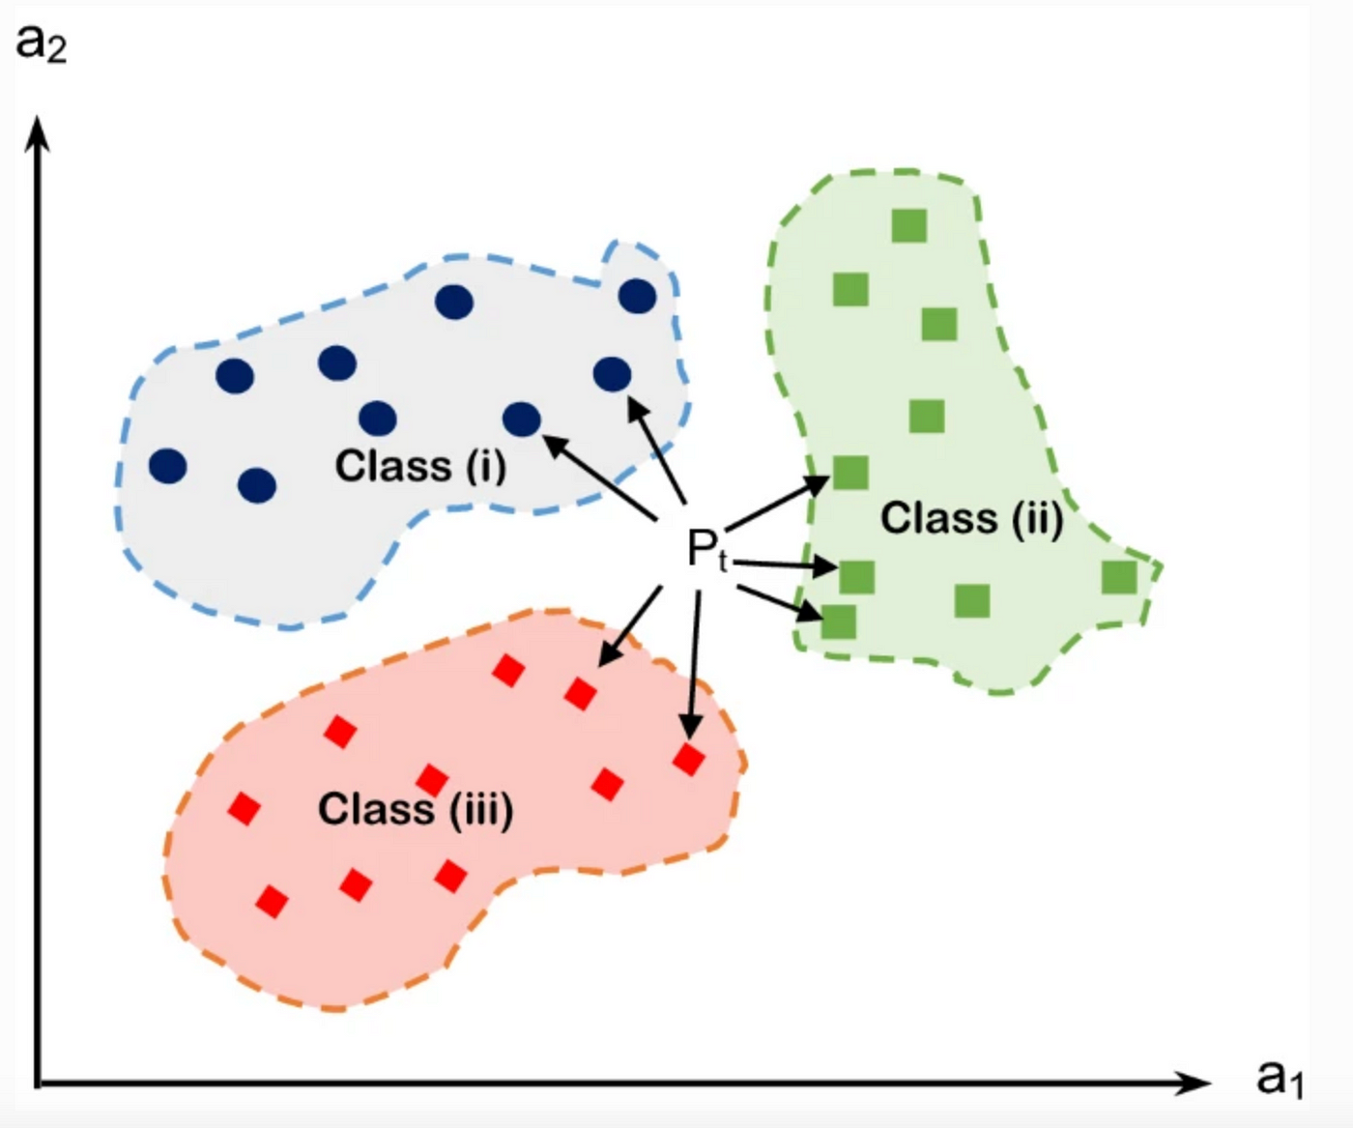
https://medium.com/data-hackers/knn-k-nearest-neighbor-o-que-%C3%A9-aeebe0f833eb

